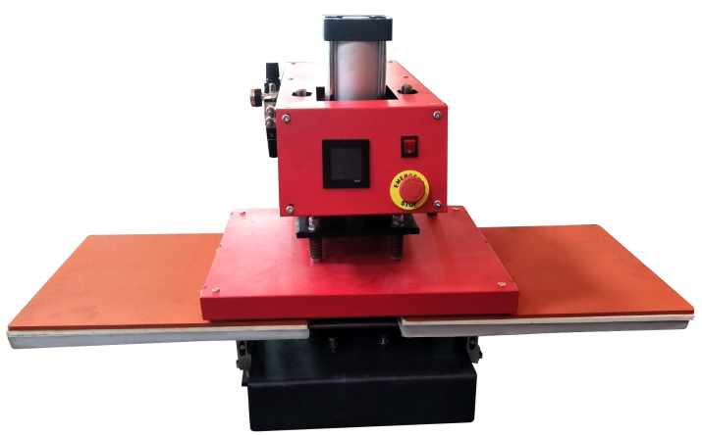
Automatic Double Location Transfer Machine

Operator s' Manual(CE)
Technical characteristics：
Pictures or text printed by dissolved sublimation ink can be transferred onto the fabrics made of cotton and flax, it can also be used to heat transfer on the materials with planted hair and foaming materials, it is economic and convenient.

This machine is not suitable for minors to use or food processing

Specification:
Printing Area(mm) | 40*50 | 40*60  Features:  1.This machine has adopted advanced electronics technology assisted with penumatic principle . Automatically work, easy to operate , safe and reliable.  2.The enlarged and thickened Alumi num heat board, heat evenly, and especially suitable for larger area transferring .
Voltage | 110/220V
Power(W) | 2700 | 2800
Temperature(℃) | 0-399
Time Rnge(s) | 0-999
Packing Size(cm) | 135*75*95
Gross Weight(kg) | About100-130KG

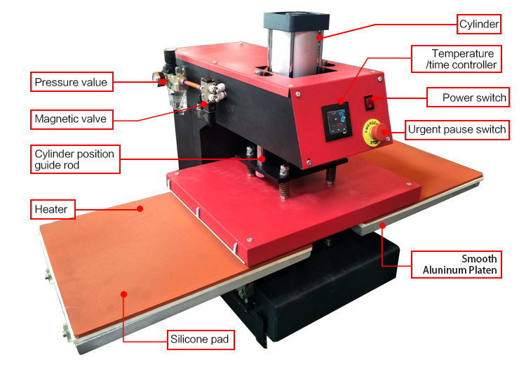

Operation of the instrument：
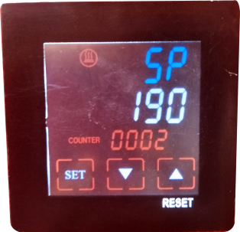
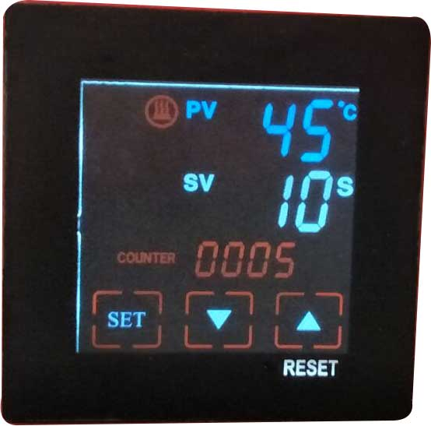
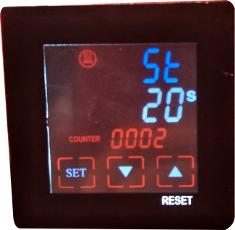

1.Press“SET”button,
display“ SP ”,press“ ”“ ”began to set the temperature.

3.Press“SET”button,
for 3 sec,finish setting
2.Press“SET”button again,display“S ”,
press“ ”“ ”began to set the time.

When changing the heating element,please remember to turn off the power and take off the power plug first,or it will burn the heating elements.

Operating instructions：
1. Please put the material on working table,adjust the pressure knob get right pressure required
2. Connect power plug and turn on power
3. Set time & temp you want with temp/time gauge get required numbers.
4. The temp for heating plate will start to rise up, when it reaching temp you set, please the material on the working tale and close the handle.
5. The buzzer will sound when reaching time you set, release the handle and take out the material

Note：
1. Because the materials and thickness of these materials are different, so the temp and time also required different.
2. Pls try a small sample to get the right temp and time needed before large quantities printing.
3. Clothing require temp about 180℃，Fabric clothing use with sublimation paper:30-50sec,100%cotton clothing use transfer paper:15-20sec.
4. Don’t use your hand to touch the heating plate directly, for prevent your hand from burns
5. Don’t put your hand on the working plate when the machine is working, for prevent your hand from burns

 | Problem | Cause | Handling methods
1 | Picture burning | Too much time or temp | Adjust time or temp
2 | Fails to heat up,but display well | Heating plate or relay broken | Check the heating plate or relay
3 | Lack of color,faded image. | Insufficient temperature and/or press time. | Adjust the temperature or increase the  heating time or increase the pressure
4 | Darkened,deep color,blurred image. | Pressed for too long, temperature too high | Adjust the temperature and heating time.
5 | No action after turn on power | Plug whether touch well. Fuse whether burn | Check the plug and fuse
6 | The real temp pass over setting temp | Relay broken or the instrument broken | Replace the relay or the instrument
7 | Temperature is normal,  timer is not working | Timer switch broken or instrument broken | Replace the timer switch or instrument
8 | Temperature is normal,  the buzzer not working | Instrument broken or buzzer broken | Replace the instrument or the buzzer
9 | When the heating plate press down,  it can’t open or open automatically. | The adjustable screw is too tight or too loose | Adjust the adjustable screw

