Cap Heat Press Machine Manual

SUMMARY
This machine can thermo-transfer (via sublimation) colorful pictures and words onto cap or similar curved products made of polyester, cotton, flax, chemical fiber, nylon, etc.

Technical Parameters
Voltage: 110V/220V
Power: 380W
Temperature range: 0-399℃
Time control range: 0-999 Sec
Temperature error band: +/-5 degrees
Heater size: 15*8cm
Gross Weight: 15kg
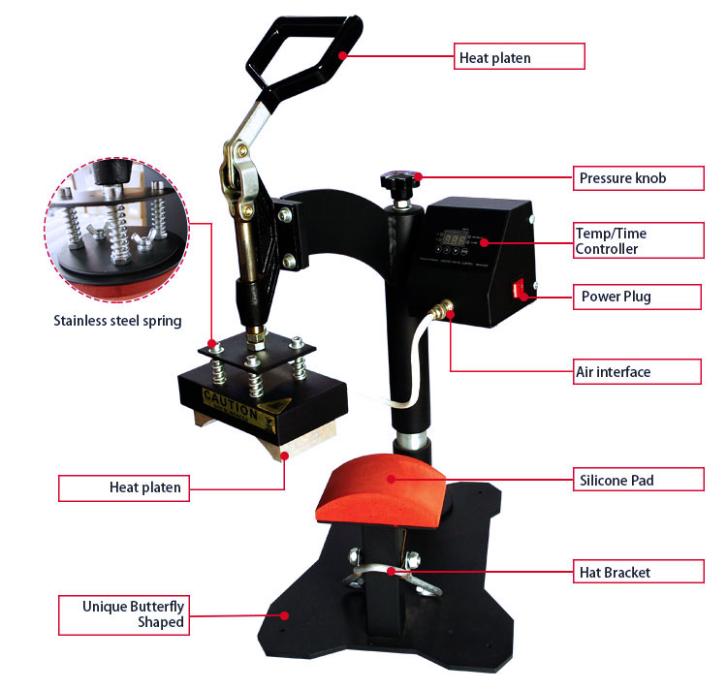

Read before operating
- Be sure to operate with a safe ground wire! Check the voltage before using this machine.
- After finishing your work, please turn the machine off.
- Don’t touch the heater when the machine is on or when its temperature is still high after turning it off.
- Keep out of the reach of children.

Suggested Time and Temperature
Materials | Time (Seconds) | Temperature (Celsius Degree)
Color cap (polyester) | 30-35 | 180-190
Cap (cotton & polyester) | 25-30 | 180-190

Note: The information and parameters given above are for reference only, specific parameters might vary depending on the materials you use and the outcome you try to achieve.

Operation

- Set the pressure
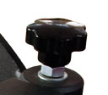
You can use the pressure knob to adjust the pressure, turning it clockwise will increase the pressure. Please pull the handle up and press it down to see whether the pressure is suitable (before starting the intended operations).

2. Setting the Time & Temperature
1) Set temperature: Press "OK" button, panel shows “ P-1”, press ▼▲to set the temperature
2) Set Time: after setting temperature, press "OK" button again ,panel shows “P-2”, press ▼▲ to set the time.
3) Save setting: Press “OK” button for 3 seconds to save the temperature and time. Machine starts to heat up automatically.
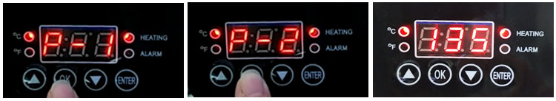

4) Remark for other setting:
A. P-3 shown on panel, you can press ▼▲to exchange Celsius and Fahrenheit degree meter
℃: Celsius degree indicator light (when this light up, it means you are using Celsius degree meter)
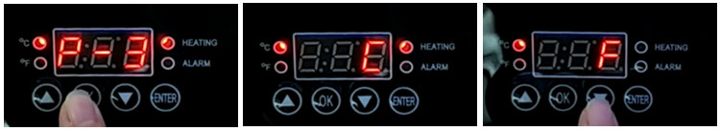
℉：Fahrenheit degree indicator light (when this light up, it means you are using Fahrenheit degree meter)

B. P-4 shown on panel, you can press ▼▲to set temperature deviation (please do not set temperature deviation without technicians’ support)
C. ENTER button is for time countdown. When reach to target temperature, press “ENTER” button, machine will countdown automatically.

3. Preparing the Sublimation Paper
Print the designed image on the sublimation paper or print with the sublimation ink on the color inkjet paper. Remember to choose mirror image(except dark cotton paper used heat transfer paper). Do not use the sublimation paper until the ink is dry.

4. Preparing the sublimation blank (e.g.: cap)
Stick the sublimation paper with image on the cap firmly using heat-resistant tape. Place the cap on the work table.

5. Begin sublimation printing
When reach to the target temperature, press the heater down to start sublimation printing. THE TIMER WILL START WORKING AUTOMATICLY and countdown after heater down.

6. Finish
When the timer countdowns to zero and the buzzer rings, please raise the handle up to open the heater, and then take out the cap from the heater carefully.
Move the sublimation paper after cooling for a while and you will see the designed image is well pressed on the cloth.

Please Note
- Be careful of the hot heating surface!!
- Please make sure the heating temperature and transfer time are correct
- In order to extend the service life of this machine, please turn the machine off for 15 minutes after using it continuously for 4 hours.
- You may refer to “Suggested Time and Temperature” chart to determine the suitable temperature and time according to the material.
- Each time you put through power supply and turn power switch on, the heater will take some time (about 20 minutes) to warm up to reach the target temperature for the first press.
6. When changing the heating element, please remember to turn off the power and take off the power plug first, or it will burn the heating elements.

COMMON PRINTING FAILURES and THEIR POSSIBLE REASONS
- The color is lighter: the temperature is too low; OR the pressure is not even; OR the time is too short.
- The design is indistinct: the time is too long which led to ink diffusion.
- The design has no luster: the pressure is too high; OR the temperature is too high.
- Part of design is indistinct: heat printing zone OR the heating is not even.
- Scar on design: heat printing time is too long.
- Depth of color is not the same: pressure not even OR the coating is not even.
- Paper stick to the object: the temperature is too high; OR the coating of the object is not good.
- Please do not set the temperature to more than 250°C or it will shorten the service life of the machine.

