HEAT PRESS MACHINE
Operator s' Manual(CE)

Summary
A heat press machine is the machine that presses a transfer onto an imprintable substrate . Using high temperatures and pressures for a certain amount of time, the transfer is permanently embedded into the product.Heat presses are recommended for professional and satisfying results simply because standard laminating devices and home hand irons can not get even near the temperatures required for a reliable transfer.

Technical Parameters
Work Size：29*38/38*38cm
Voltage：110/220V
Power：900W
Temperature：0-399°C
Time for heating up：10-15 minutes
Packing Size：52*50.5*38/ 56*47*41.5 cm
Gross Weight：19.7/ 21.9KG
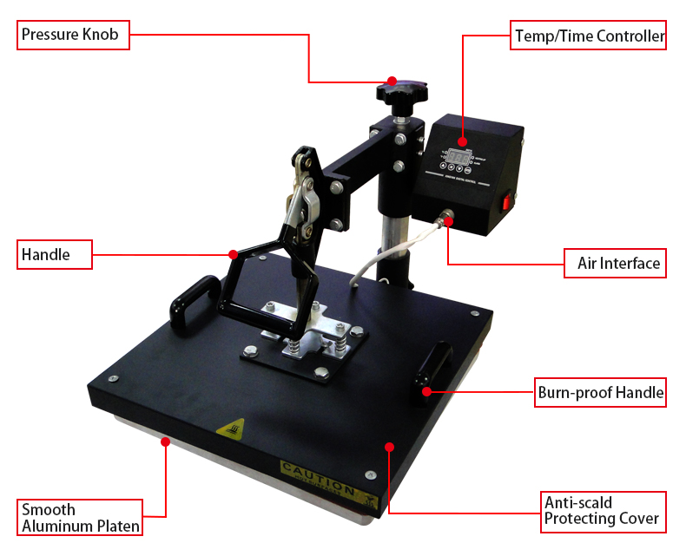
Read before operating :
1. Be sure to operate with a safe ground wire! Check the voltage before using this machine.
2. After finishing your work, please turn the machine off.
3. Don’t touch the heater when the machine is on or when its temperature is still high after turning it off.
4. Keep out of the reach of children.

Operation：
- Set the Pressure
You can use the pressure knob to adjust the pressure, turning it clockwise will increase the pressure. Please pull the handle up and press it down to see whether the pressure is suitable (before starting the intended operations).
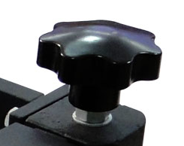
2. Setting the Time & Temperature
1) Set temperature: Press "OK" button, panel shows “ P-1”, press ▼▲to set the temperature
2) Set Time: after setting temperature, press "OK" button again ,panel shows “P-2”, press ▼▲ to set the time.
3) Save setting: Press “OK” button for 3 seconds to save the temperature and time. Machine starts to heat up automatically.
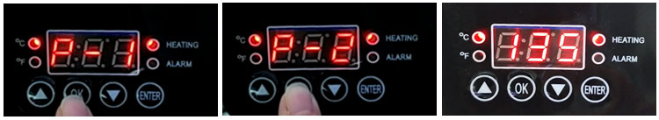

4) Remark for other setting:
A. P-3 shown on panel, you can press ▼▲to exchange Celsius and Fahrenheit degree meter
℃: Celsius degree indicator light (when this light up, it means you are using Celsius degree meter)
℉：Fahrenheit degree indicator light (when this light up, it means you are using Fahrenheit degree meter)

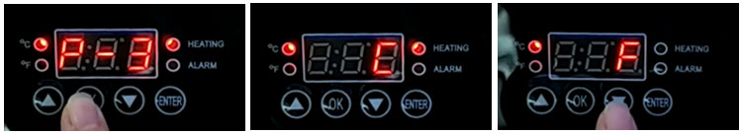

B. P-4 shown on panel, you can press ▼▲to set temperature deviation (please do not set temperature deviation without technicians’ support)
C. ENTER button is for time countdown. When reach to target temperature, press “ENTER” button, machine will countdown automatically.

ATTEN：
The function of the temp controller is complex，please don’t press any button for other operation unless you set up the temp ,otherwise the process of the controller will be damaged !!! especially please ignore the display P-4 , because P-4 display is a professional proofreader between actual correct temperature and wrong temperature shown on controller .When technician find the temperature shown on controller is a lot different from actual correct temperature , Please press “OK” button for long time to display P-4 , and then use any negative number(-50-0) or positive umber(0-+50)to rectify accordingly .These data must be operated only by technicians.

3. Preparing the Sublimation Paper
Print the designed image on the sublimation paper with the sublimation ink. Remember to choose mirror image(except dark color cotton used heat transfer paper). Do not use the sublimation paper until the ink is dry.

4. Preparing the sublimation blank
Prepare the t shirt, place it on the t shirt heater (t shirt should lie on the board flat and even).

5. Begin sublimation printing
When reach to the target temperature, place the sublimation paper with the t shirt. Press the heater down to start printing.

6. Finish
When the timer countdowns to zero and the buzzer rings, please raise the handle up to open the heater, and then take out the t shirt and paper carefully.
Move the sublimation paper and you will see the designed image is well pressed on the t shirt.

Please Note：
1. Be careful of the hot heating surface
2. Please make sure the heating temperature and transfer time are correct
3. In order to extend the service life of this machine, please turn the machine off for 15 minutes after 4. using it continuously for 4 hours.
5. You may refer to “Suggested Time and Temperature” chart to determine the suitable temperature and time according to the material.
6. Each time you put through power supply and turn power switch on, the heater will take some time to warm up to reach the target temperature for the first press.

COMMON PRINTING FAILURES and THEIR POSSIBLE REASONS
1. The color is lighter: the temperature is too low; OR the pressure is not even; OR the time is too short.
2. The design is indistinct: the time is too long which led to ink diffusion.
3. The design has no luster: the pressure is too high; OR the temperature is too high.
4. Part of design is indistinct: heat printing zone OR the heating is not even.
5. Scar on design: heat printing time is too long.
6. Depth of color is not the same: pressure not even OR the coating is not even.
7. Paper stick to the object: the temperature is too high; OR the coating of the object is not good.
8. Please do not set the temperature to more than 250°C or it will shorten the service life of the machine.

