LCD Double Station Pneumatic Heat Press Machine User Manual
Summary
This machine can thermo-transfer (via sublimation) colorful pictures and words onto textiles made of cotton, flax, chemical fiber, nylon, etc. This machine can also conduct some heat-treatments such as hair-planting print, vesicant print, and conglutination of clothes with their lining under lower temperature and lower pressure (such as the conglutination of kid’s clothes, caps and shoes).
it is air press pneumatic, auto work, easy operation, safe and reliable with enlarged and thickened cast aluminum heating board.

Technical Parameters
Voltage：220V
Power：2200W
Temperature：0-399°C
Time for heating up：10-15 minutes
Pressure output：6kg/C㎡ (minimum)
Work Size：40*60cm
Gross Weight: 250KG
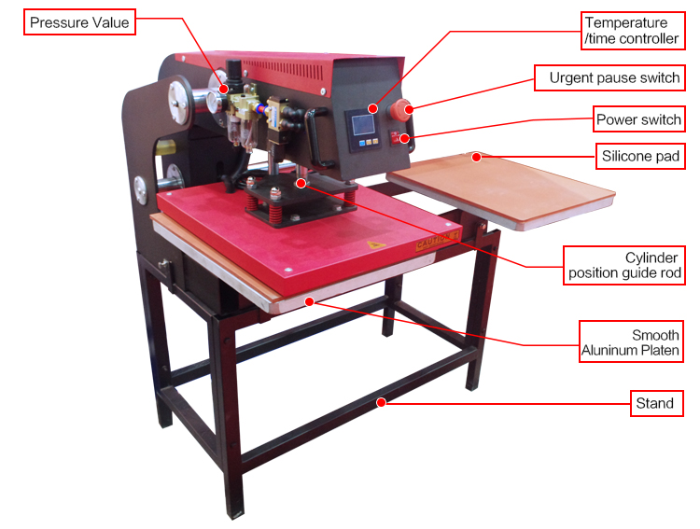
Operation
1. Read before usage
Before turn on the power, check each spare parts to make sure they are not loose.
Connect the air source, power supply and open the pressure valve to let the pressure valve to needed pressure (about 3-6kg/cm²) till the heating board rises up automatically.

2. Panel setting
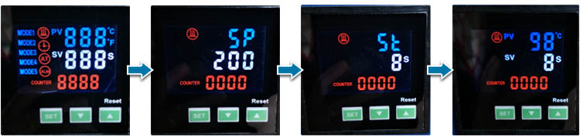

Turn on the power switch,
1): Press“SET”button, when display shows “ SP ” , you can set temperature, press ▲ for temperature increase, press ▼for temperature decrease;
2): Press“SET”button again, when display shows “SE ”, you can set time. press▲ for time increase, press▼ for time decrease;
3): Press“SET”button for 3 seconds to finish setting. Machine starts heating up.
Remark: How to use the function of RESET: The machine will automatically count the number of times for press, the times of press will show on counter display. Press "RESET" , the number of times for press will reset to zero and the counter display will restart to count

3. Pneumatic Press Up and Down
1) When reach to needed temperature, the machine will alarm, the heater will rise up;
2) Move the work table exactly under the heater, the heater will automatically press down;
3) When time is up to finish printing, the heater will rise up.
IMPORTANT NOTEICE for EMERGENCY STOP:
When machine works abnormally, please immediately press EMERGENCY STOP button to stop work; to restart, rotate the EMERGENCY STOP button and pull it out.

Please Note
1.This machine must be protected by safe and reliable ground wire.
2. During heating up and operation, please do not touch the heater to avoid scalding.
3. To get successful sublimation effect, it should be correct time, temperature and pressure; the thickness and material of the heating sublimation products and the ink and paper also will affect the sublimation effect.
4. Before large scale production, you must make some sample test to make sure the best time, temperature, pressure etc.
5. The temperature controller is complicated, except the temperature setting, please do not make other setting to avoid program error and broken.
6. Don’t put your hand on the working plate when the machine is working, for prevent your hand from burns

COMMON FAILURES and THEIR POSSIBLE REASONS
1. cylinder: when the heating board can not lift up or press down, check the pressure valve whether it has pressure or not.
2. heater can not be heating up: the panel has problem or the relay is not working or heater is broken.
3. thermocouple is broken: one line broken light will light up from the temperature display, then change the thermal couple.
4. picture burning: Too much time or temperature, just adjust time or temperature
5. picture not vivid: less time or too low temperature, just adjust to have more time or temperature

